**ASSIGNMENT-7.4:**

Write a word count program using Partitioner and implement the following logic in the Partitioner words with length 5 should go into reducer 1 and words with length 6 should go into reducer 2 and the rest of the words should go into reducer 3.

Driver Class:

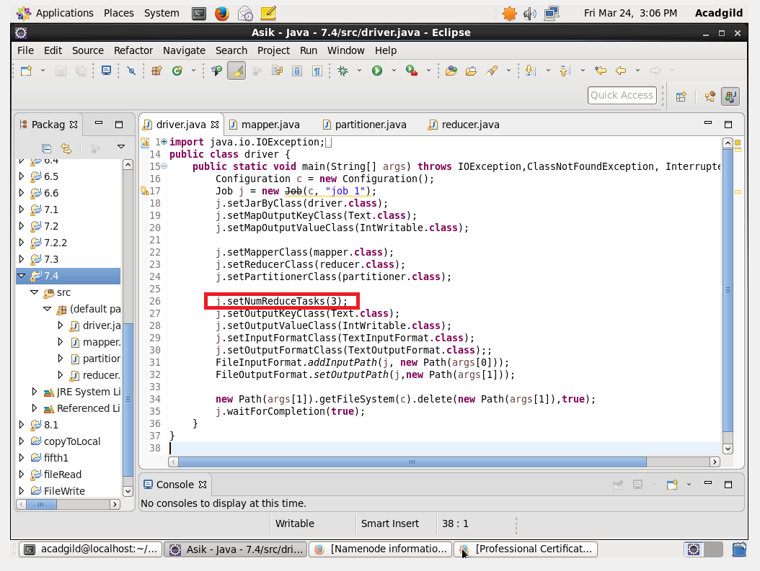

Mapper Class: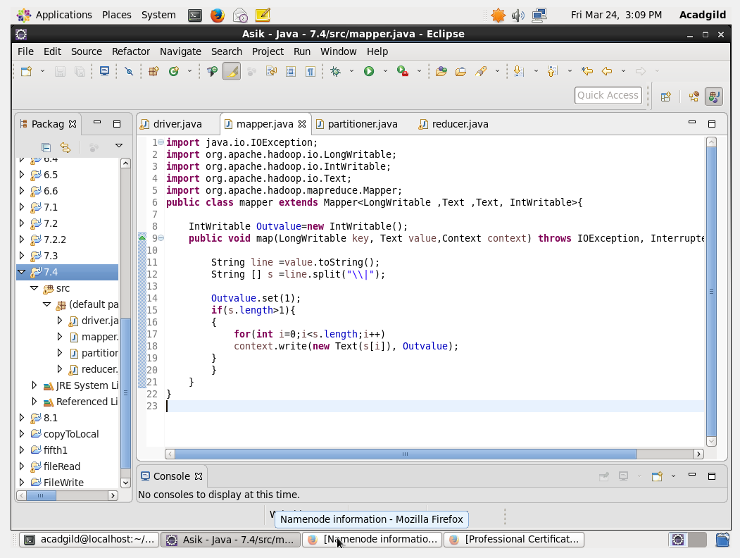

Reducer Class:

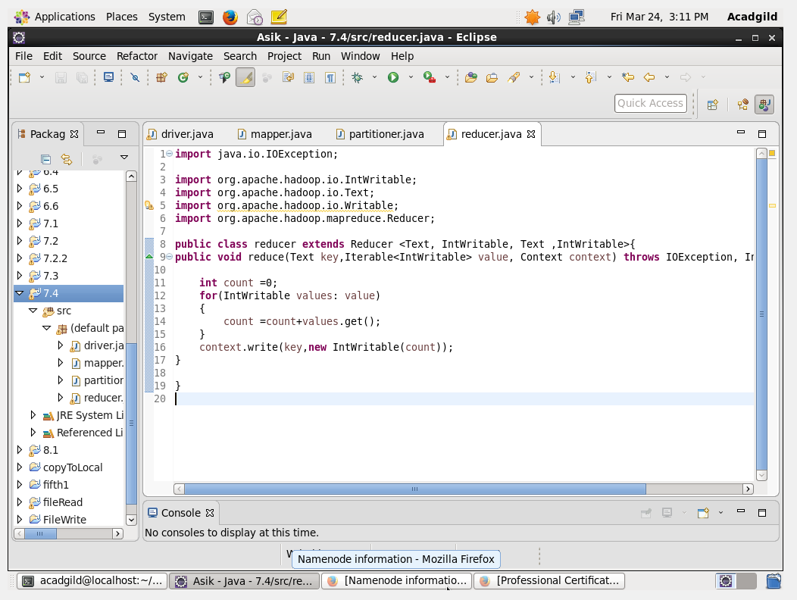

Partitioner Class:

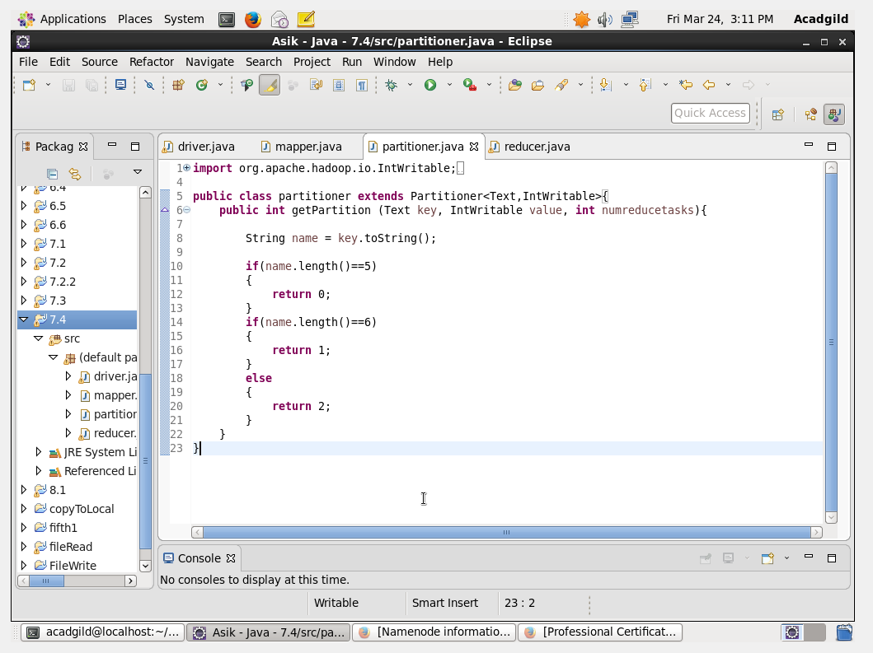

Output: